**DESCRIBING PEOPLE (PHYSICAL APPEARANCE)**

**DEFINITION**

Describing physical appearance means talking about how a person looks. This includes details about their height, body shape, hair, eyes, skin color, and other distinctive features. Giving clear descriptions helps others visualize the person you are talking about.

**EXAMPLE DESCRIBING PHSIYCAL APPEARANCE**

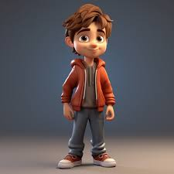

👦 Describing People – Physical Appearance (Introduction Example)

Hi, my name is Alex.

I am a boy.

I have short brown hair.

My eyes are big and brown.

I am wearing a red jacket and grey pants.

I look happy and friendly!

**VOCABULARY**

* **Height (Tinggi badan):**

1. tall /tɔːl/ — tinggi
2. short /ʃɔːrt/ — pendek
3. medium height /ˈmiːdiəm haɪt/ — tinggi sedang

* **Build (Bentuk badan):**

1. slim /slɪm/ — langsing
2. thin /θɪn/ — kurus
3. muscular /ˈmʌskjələr/ — berotot
4. average build /ˈævərɪdʒ bɪld/ — bentuk badan rata-rata
5. overweight /ˌoʊvərˈweɪt/ — kelebihan berat badan

* **Hair (Rambut):**

1. long /lɔːŋ/ — panjang
2. short /ʃɔːrt/ — pendek
3. curly /ˈkɜːrli/ — keriting
4. straight /streɪt/ — lurus
5. wavy /ˈweɪvi/ — bergelombang

* **Hair Colors (Warna rambut):**

1. black /blæk/ — hitam
2. brown /braʊn/ — coklat
3. blonde /blɑːnd/ — pirang
4. red /rɛd/ — merah (rambut merah)
5. gray /ɡreɪ/ — abu-abu

* **Eyes (Mata):**

1. big /bɪɡ/ — besar
2. small /smɔːl/ — kecil
3. blue /bluː/ — biru
4. green /ɡriːn/ — hijau
5. brown /braʊn/ — coklat
6. black /blæk/ — hitam

* **Skin (Kulit):**

1. fair /fɛər/ — cerah / putih
2. dark /dɑːrk/ — gelap
3. tan /tæn/ — kecoklatan
4. pale /peɪl/ — pucat

* **Other Features (Ciri lain):**

1. wear glasses— memakai kacamata
2. beard /bɪərd/ — jenggot
3. mustache /ˈmʌstæʃ/ — kumis
4. freckles /ˈfrɛklz/ — bintik-bintik (di wajah)
5. dimples /ˈdɪmpəlz/ — lesung pipi

# **COMMON VOCABULARY FOR PHYSICAL APPEARANCE**

### Height

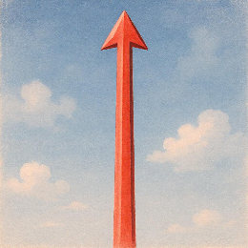

Tall **/tɔːl/**

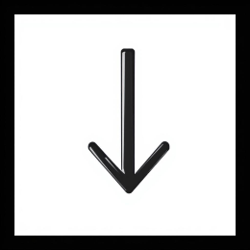

Short **/ʃɔːrt/**

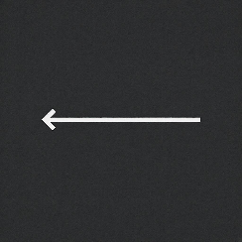

Medium height **/ˈmiːdiəm haɪt/**

### Build

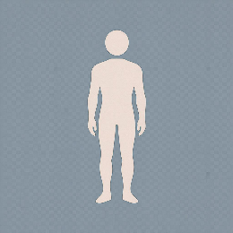

Slim **/slɪm/**

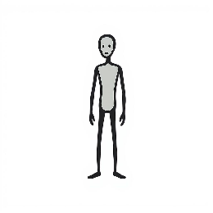

Thin **/θɪn/**

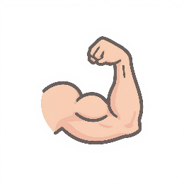

Muscular **/ˈmʌskjələr/**

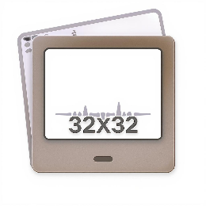

Average build **/ˈævərɪdʒ bɪld/**

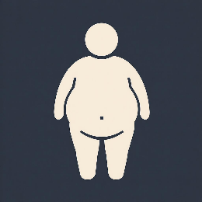

Overweight **/ˌoʊvərˈweɪt/**

### Hair

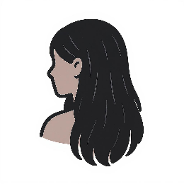

Long hair **/lɔːŋ hɛər/**

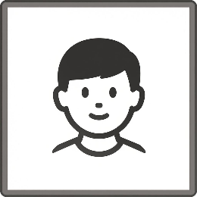

Short hair **/ʃɔːrt hɛər/**

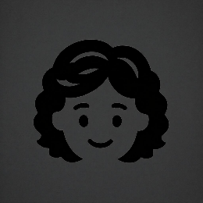

Curly hair **/ˈkɜːrli hɛər/**

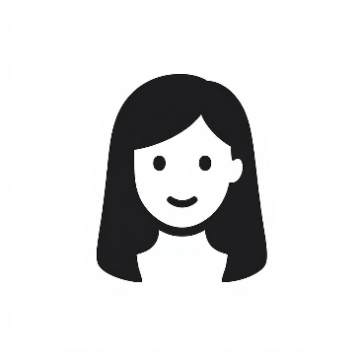

Straight hair **/streɪt hɛər/**

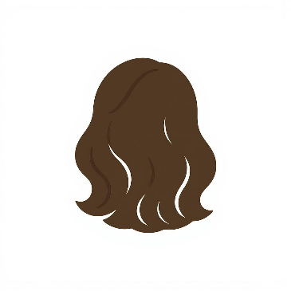

Wavy hair **/ˈweɪvi hɛər/**

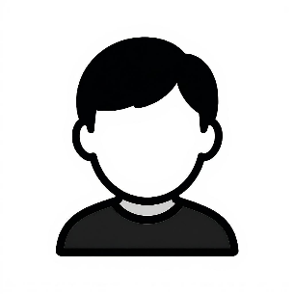

Black hair **/blæk hɛər/**

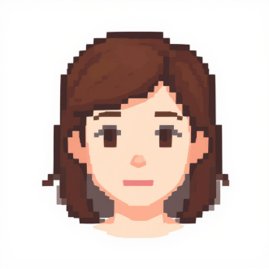

Brown hair **/braʊn hɛər/**

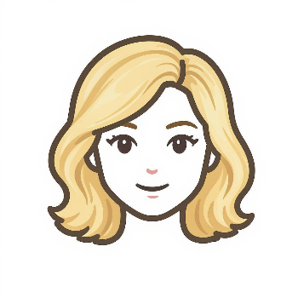

Blonde hair **/blɑːnd hɛər/**

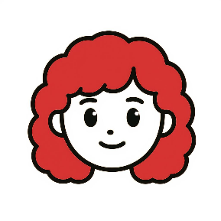

Red hair **/rɛd hɛər/**

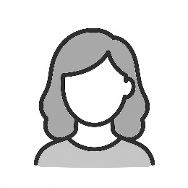

Gray hair **/ɡreɪ hɛər/**

### Eyes

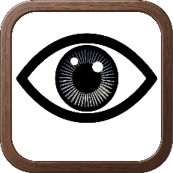

Big eyes **/bɪɡ aɪz/**

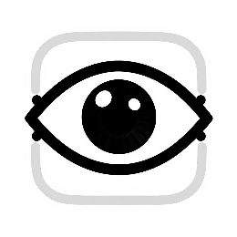

Small eyes **/smɔːl aɪz/**



Blue eyes **/bluː aɪz/**



Green eyes **/ɡriːn aɪz/**

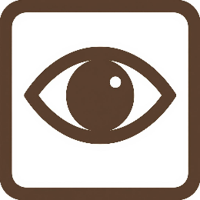

Brown eyes **/braʊn aɪz/**

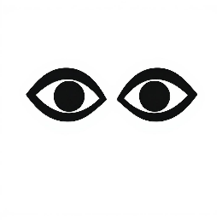

Black eyes **/blæk aɪz/**

### Skin

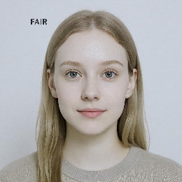

Fair skin **/fɛər skɪn/**

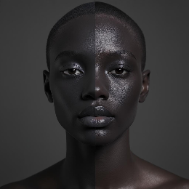

Dark skin **/dɑːrk skɪn/**

4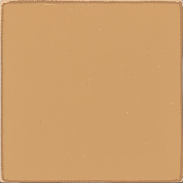

Tan skin **/tæn skɪn/**



Pale skin **/peɪl skɪn/**

### Other Features

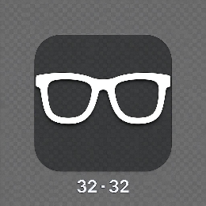

Wears glasses **/wɛərz ˈɡlæsɪz/**

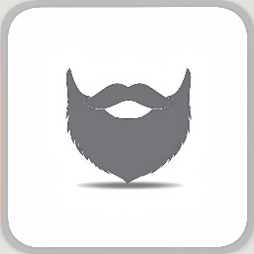

Beard **/bɪərd/**



Mustache **/ˈmʌstæʃ/**

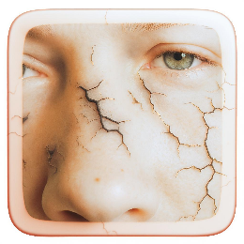

Freckles **/ˈfrɛklz/**

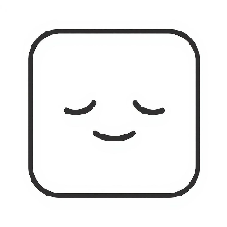

Dimples **/ˈdɪmpəlz/**

**GAME (DI ATAS SOAL ADA GAMBAR SESUAI JAWABAN )**

1. **Tinggi**

Tall

/tɔːl/

He is very ______.

(a) tall (b) short (c) slim)

1. **Wavy hair**

rambut bergelombang

/ˈweɪ.vi/

She has ______ hair.

(a) straight (b) curly (c) wavy

1. **Tan skin**

kulit sawo matang

/tæn/

He has ______ skin.

(a) pale (b) tan (c) fair

1. **Muscular**

berotot

/ˈmʌs.kjə.lər/

He is very ______.

(a) overweight (b) muscular (c) thin)

1. **Wears glasses**

memakai kacamata

/wɛəz ˈɡlɑː.sɪz/

She ______ glasses.

1. eats (b) wears (c) sees)
2. **Overweight**

kelebihan berat badan

/ˌəʊ.vəˈweɪt/

He is a bit ______.

(a) slim (b) overweight (c) tall)

1. **Pale skin**

kulit pucat

/peɪl/

The baby has ______ skin.

(a) tan (b) dark (c) pale)

1. **Blue eyes**

mata biru

/bluː/

She has beautiful ______.

(a) blue eyes (b) brown hair (c) big lips

1. **Short straight hair**

rambut pendek lurus

/ʃɔːt streɪt/

He has ______.

(a) curly long hair (b) short straight hair (c) wavy blonde hair

1. **Dimples**

lesung pipi

/ˈdɪm.pəlz/

She has cute ______.

(a) freckles (b) glasses (c) dimples